**PRACTICAL NO :5**

Write a program using Selenium WebDriver to update 10 student records in an Excel file. Perform data manipulation and verification.

* **Input :**

**1st You Create a Excel File**

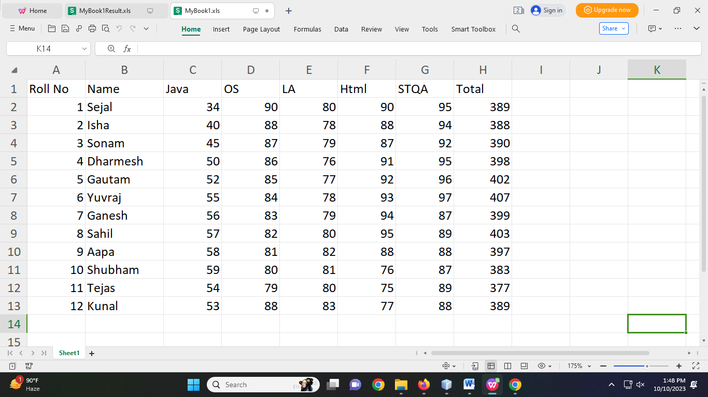

* **Code in NetBeans:**

package sejalexcel;

import java.io.FileInputStream;

import java.io.FileNotFoundException;

import java.io.FileOutputStream;

import java.io.IOException;

import jxl.Sheet;

import jxl.Workbook;

import jxl.read.biff.BiffException;

import jxl.write.Label;

import jxl.write.WritableSheet;

import jxl.write.WritableWorkbook;

import jxl.write.WriteException;

/**

*

* @author Sejal Sawant

*/

public class SejalExcel {

public static void main(String[] args) throws FileNotFoundException, BiffException, IOException, WriteException {

FileInputStream is = new FileInputStream("D:\\@TYCS\\Software Testing & Quality\\Practical 5\\MyBook1.xls");

Workbook w= Workbook.getWorkbook(is);

Sheet s=w.getSheet(0);

String a[][] = new String[s.getRows()][s.getColumns()];

FileOutputStream os;

os = new FileOutputStream("D:\\@TYCS\\Software Testing & Quality\\Practical 5\\MyBook1Result.xls");

WritableWorkbook wb = Workbook.createWorkbook(os);

WritableSheet ws = wb.createSheet("Result", 0);

int i=0,j=0;

for(i=0;i<s.getRows();i++){

for(j=0;j<s.getColumns();j++){

a[i][j]=s.getCell(j,i).getContents();

Label l1 = new Label(j,i,a[i][j]);

ws.addCell(l1);

}

}

Label L2=new Label(j,0,"result");

ws.addCell(L2);

for(i=1;i<s.getRows();i++){

for(j=2;j<s.getColumns();j++){

a[i][j]=s.getCell(j,i).getContents();

int x=Integer.parseInt(a[i][j]);

if(x>=40){

Label l1 = new Label(8,i,"PASS");

ws.addCell(l1);

}else{

Label L=new Label(8,i,"FAIL");

ws.addCell(L);

break;

}

}

}

wb.write();

wb.close();

System.out.println("Data Copied successfully");

}

}

* **Output :**

